Leaf Station:
Chloroplast

1. Complete the table with the missing components from the image of the chloroplast provided at the station. Decide if the missing component is matter, energy, or neither and enter into the table.
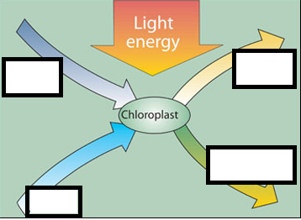
 | Missing component | Matter/Energy/Neither  B  A  E  D  C
A
B
C
D
E

2. Predict the process that is taking place in the chloroplast: _________________________________________

3. Why is it important for a plant to contain chloroplasts?

4. Why is it important for a plant to contain chlorophyll?

5. Why do you think some plants have wider leaves than others?

Stomata

6. Complete the table with the missing components from the image of the stomata provided at the station. Decide if the missing component is matter, energy, or neither and enter it into the table.
1
2
3
 | Missing component | Matter/Energy/Neither
1
2
3
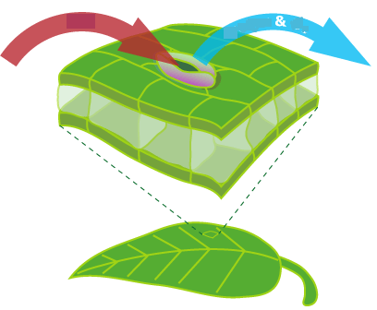

7. Predict the process(es) that is/are taking place in the stomata: _____________________________

8. What is the function of a guard cell?

9. Why do you think some plants have a thick waxy coating on their leaves?

Flower Station:
Instructions: Use the flower diagram to help complete the table below.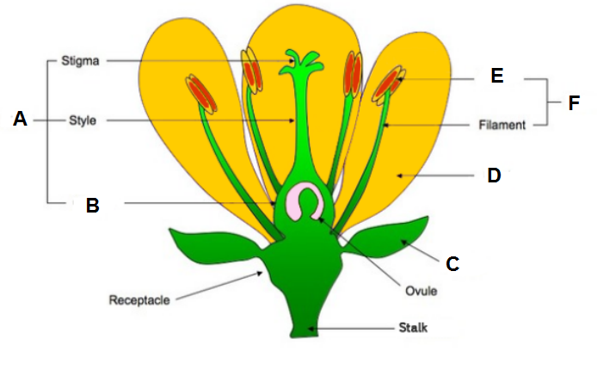
Location | Name of the Part | Describe the Function
A
B
C
D
E
F
Sepals Anther Pistil Petal Stamen Ovary
Describe the process of Pollination:

Roots and Stem Station:

Name of the Plant Part | Describe | Does it transfer  Matter/Energy/Neither?
Roots | The function:  What it transfers:
Stems | The function:  What it transfers:
Xylem | The function:  What it transfers:
Phloem | The function:  What it transfers:

Roots hold the plant in the ground and absorb water & nutrients from the soil.
Xylem is the system of tissues that delivers water and nutrients up a plant system.

Phloem is the system of tissues that transport mainly sugar to all different parts of the plant so it can live and grow.

